**Event Store**

Event Store is used in DNIF in order to manually upload data using static files in formats like. json, .csv, .xls and .xlsx and thus carry out further analysis created event store, thus enabling the user to create queries, make useful reports, create and visualize data using dashboard as well.

**Steps to upload data using Event Store**:

**Step 1:** Login using DNIF Console at <https://go.dnif.it/>

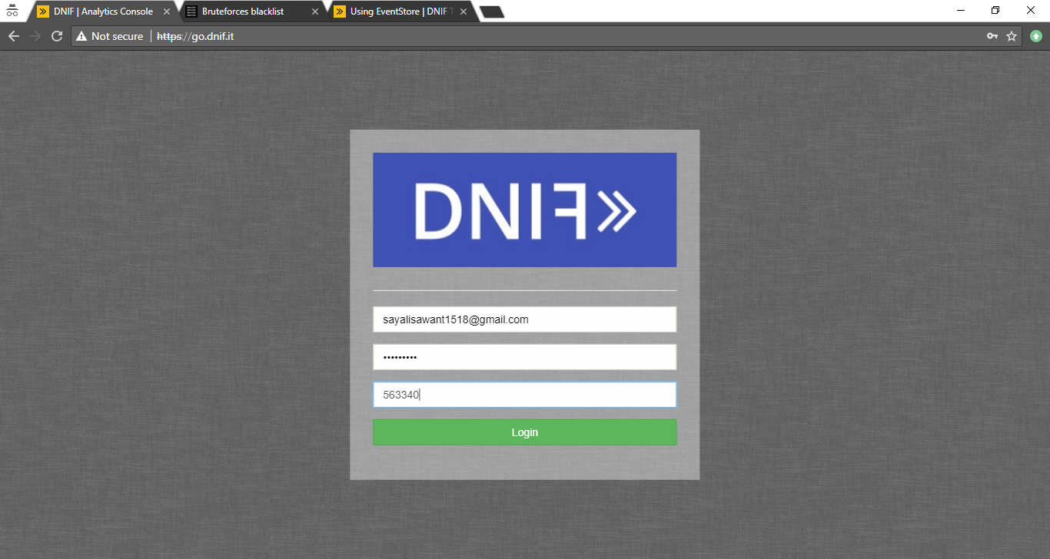

**Step2:** Once logged in to the DNIF Console, check for connection setup for the repository under the Connections option available under “Management” Tab as shown below.

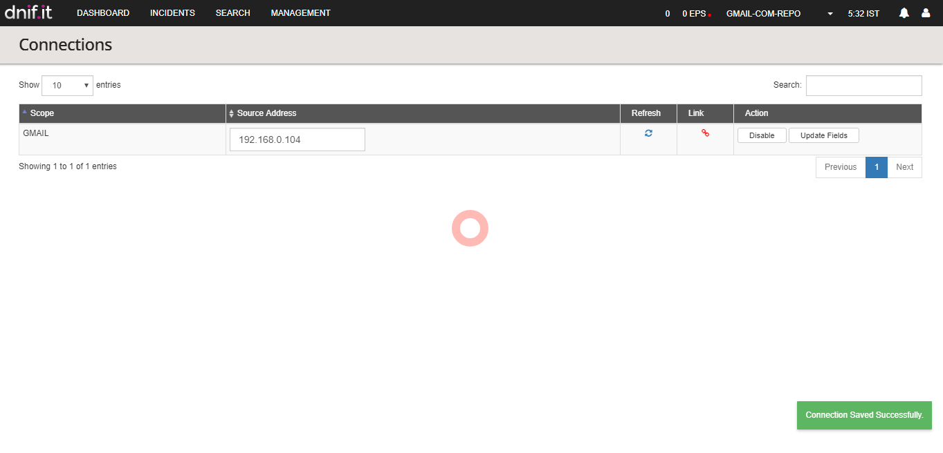

**Step 3:** After the connection is successfully established, navigate to the “Search” Tab and click on “Settings” icon as shown below on the top left corner of the screen and further click on “Event Store” option.

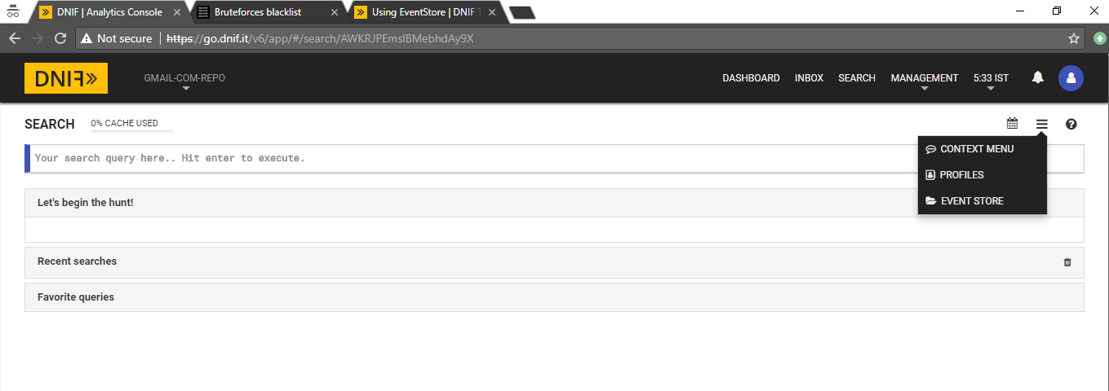

**Step 4:** After clicking on “Event Store” option, the following “Create Event Store” window appears as shown below:

In the “Create Event Store” window, enter the following details:

1. Store Name
2. Store Type
3. Create a Empty Event Store
4. Create and Upload Event Store
5. Upload a file (in json/xslx/csv format)
6. Clicking “Upload” allows you to browse a file from your machine in any of the supported formats - *csv*, *json*, *xls* or *xlsx*. This uploaded file must be less than 100 MB in size.

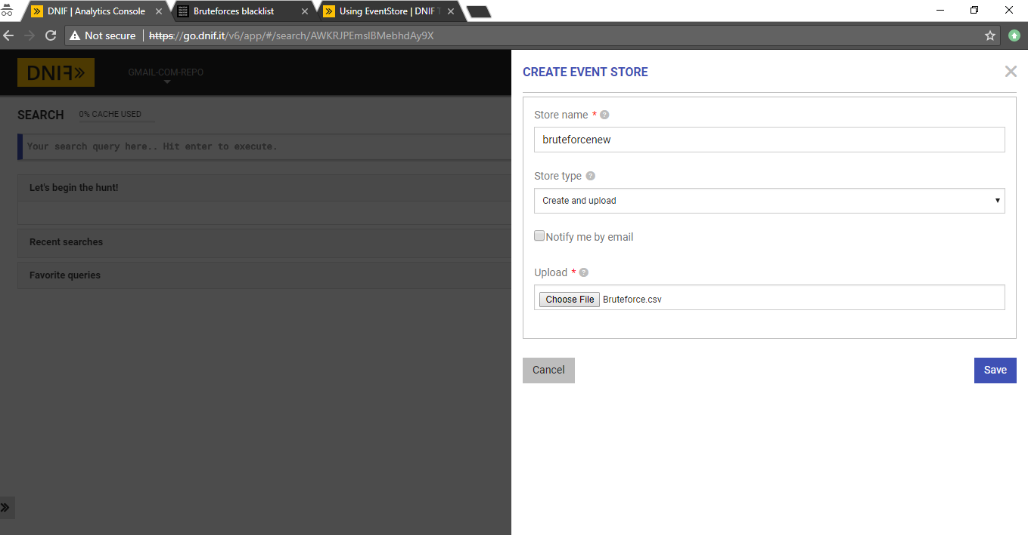

Click on “Save” button .

**Step 5:** Under Management Tab, Click on Event store to check the created event store as shown in the screenshots below for “**bruteforcenew**” event store has been created under “Management” Tab in “Event Store” option.

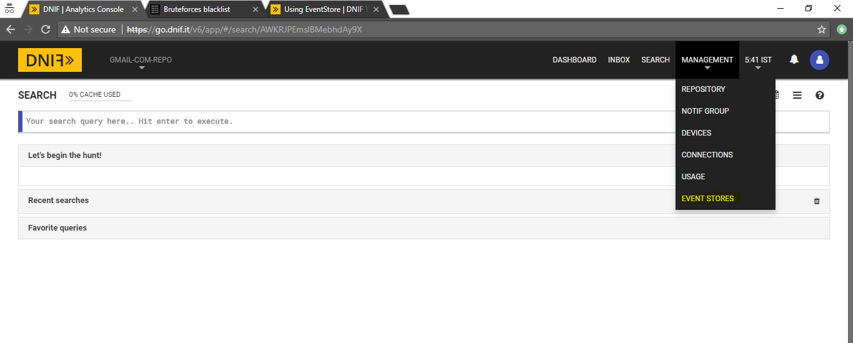

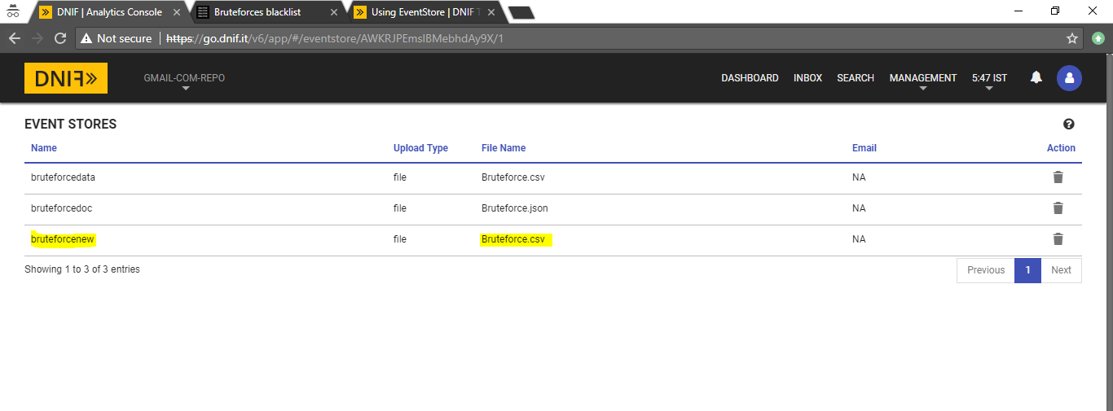

**Step 6:** Under Search Tab, now run queries using the created Event store to retrieve data and perform analysis further.

